EXPT NO: 1 | BUILDING AND TRAINING A SIMPLE ARTIFICIAL NEURAL NETWORK (ANN) FOR REGRESSION AND CLASSIFICATION
DATE:

PRE-LAB QUESTIONS (PROVIDE BRIEF ANSWERS TO THE FOLLOWING QUESTIONS)

- What is an Artificial Neural Network (ANN)?
An Artificial Neural Network (ANN) is a machine learning model inspired by the human brain. It learns patterns from data to make predictions or classifications.

- What are the functions of the input, hidden, and output layers in an ANN?
• Input Layer: Receives the input data.
• Hidden Layer: Processes the data and learns patterns.
• Output Layer: Produces the final prediction or result.

- Why is feature scaling important before training an ANN?
Feature scaling makes all input values similar in range. This helps the ANN learn faster and improves accuracy.

- Differentiate between regression and classification problems with examples.
Regression: Predicts continuous values.
Example: Predicting house prices.
Classification: Predicts categories or classes.
Example: Detecting whether a tumour is benign or malignant.

- What is the role of the activation function in a neural network?
The activation function helps the ANN learn complex patterns by deciding whether a neuron should be activated.

AIM
To understand the implementation of Artificial Neural Networks (ANN) using TensorFlow and evaluate their performance on regression and classification problems.

SOFTWARE REQUIREMENTS
- Python 3.x
- Google Colab / Jupyter Notebook
- TensorFlow 2.x
- NumPy
- Pandas
- Matplotlib
- Scikit-learn

LEARNING OBJECTIVES
After completing this experiment, students will be able to:
- Understand the architecture of an Artificial Neural Network.
- Build an ANN for regression problems.
- Build an ANN for classification problems.
- Train and evaluate neural network models.
- Compare different evaluation metrics used for regression and classification.

THEORY
An Artificial Neural Network (ANN) is a machine learning model inspired by the human brain. It consists of interconnected neurons organized into layers.
A simple ANN contains:
- Input Layer
- Hidden Layer(s)
- Output Layer
During training, the ANN learns by updating weights using Backpropagation and an optimization algorithm such as Adam Optimizer.

PART A – ANN FOR REGRESSION
DATASET: California Housing Dataset
SOURCE: Scikit-learn
DESCRIPTION
- Samples: 20,640
- Features: 8
- Target: Median House Value

FEATURES
Feature | Description
MedInc | Median Income
HouseAge | House Age
AveRooms | Average Rooms
AveBedrms | Average Bedrooms
Population | Population
AveOccup | Average Occupancy
Latitude | Latitude
Longitude | Longitude

ALGORITHM
- Import libraries.
- Load California Housing dataset.
- Split into training and testing sets.
- Standardize the features.
- Build ANN model.
- Compile the model.
- Train the model.
- Predict house prices.
- Evaluate using:
  - MSE
  - MAE
  - RMSE

Code:

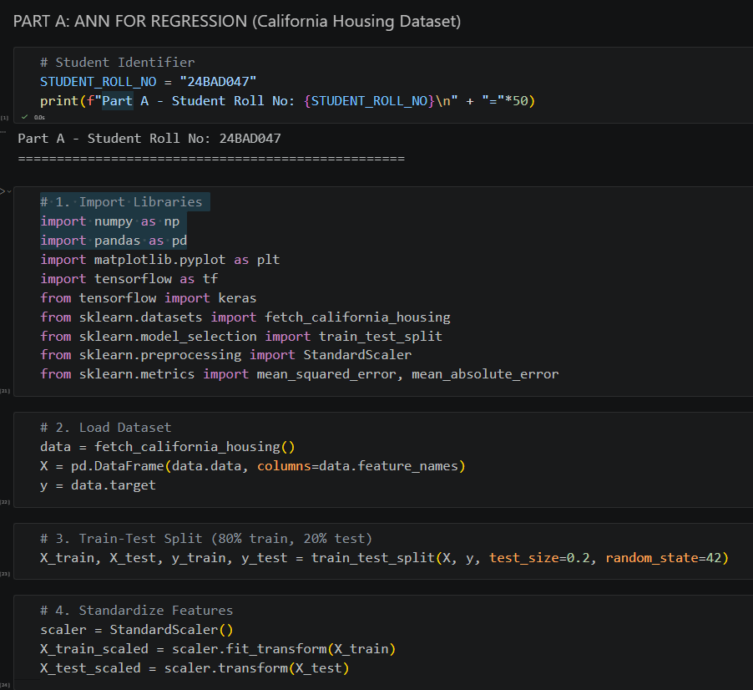
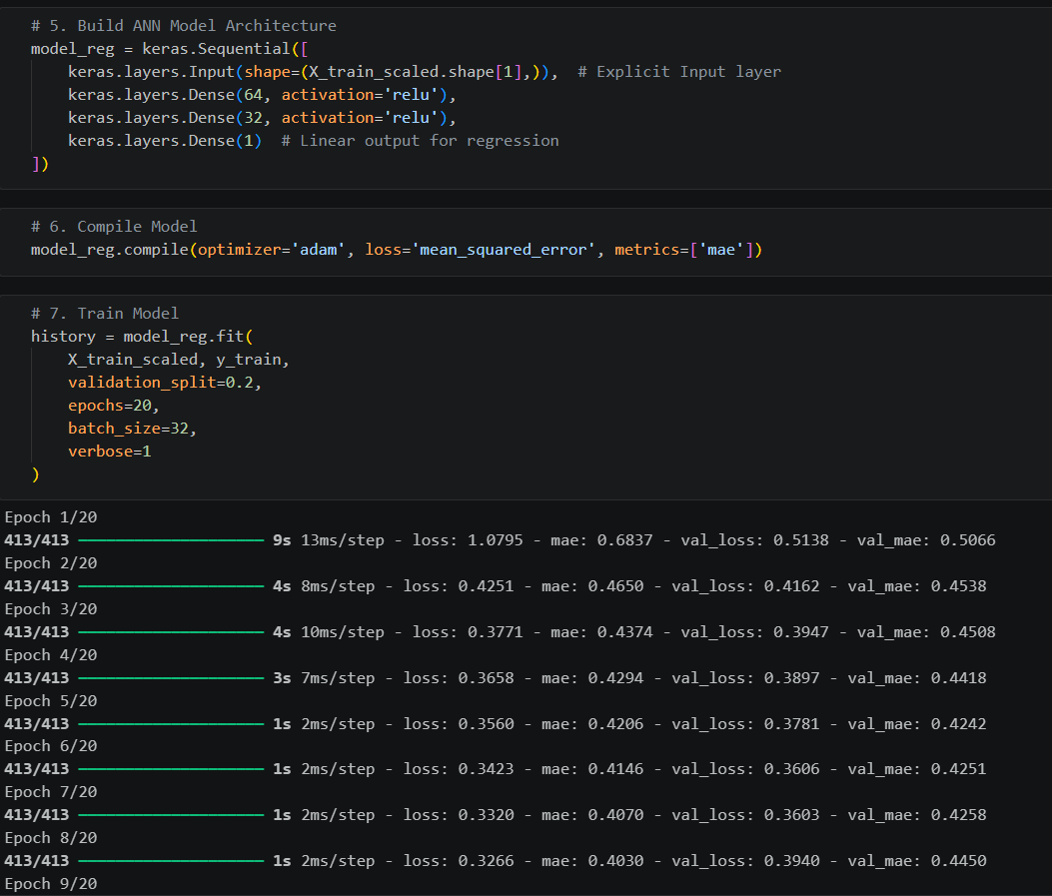
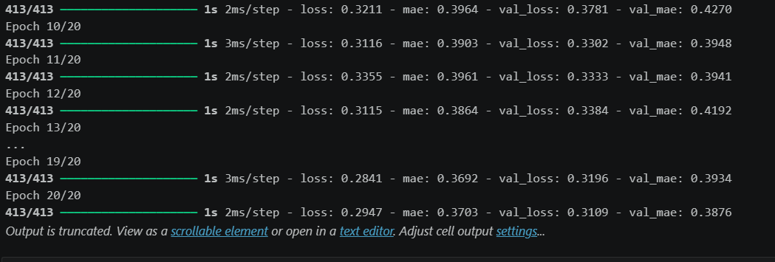

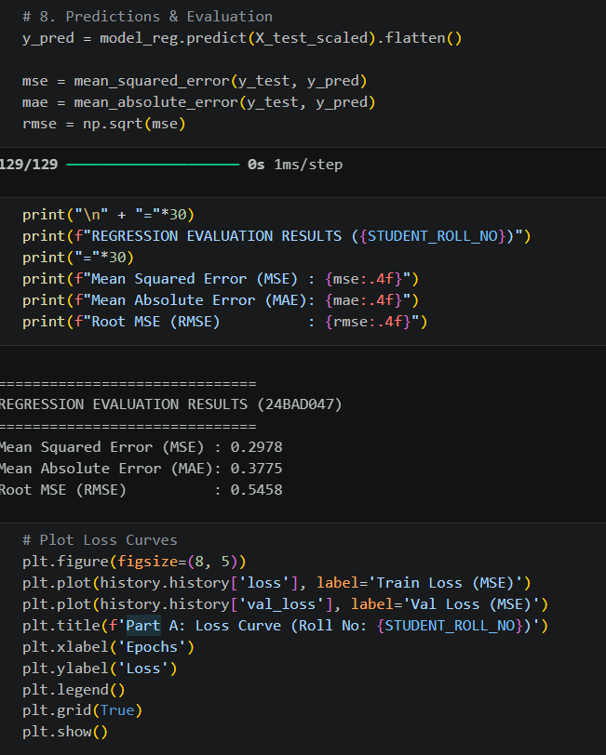

PLOT:
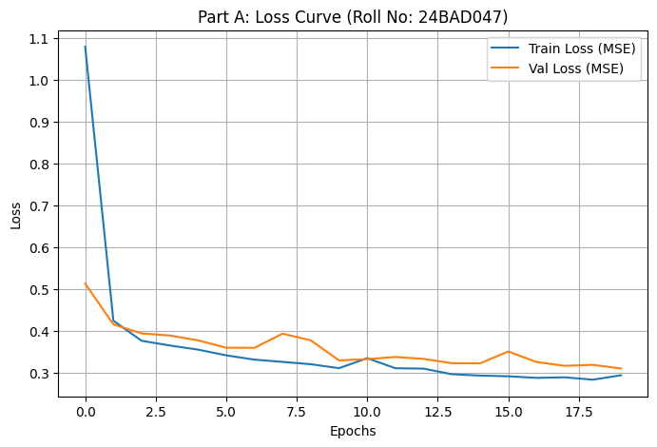

PART B – ANN FOR CLASSIFICATION
DATASET: Breast Cancer Wisconsin Dataset
SOURCE: Scikit-learn
DESCRIPTION
- Samples: 569
- Features: 30
- Classes:
  - Malignant
  - Benign

ALGORITHM
- Import libraries.
- Load Breast Cancer dataset.
- Split dataset.
- Standardize features.
- Design ANN.
- Compile model.
- Train model.
- Predict labels.
- Evaluate:
  - Accuracy
  - Precision
  - Recall
  - F1-score
  - Confusion Matrix

Code:
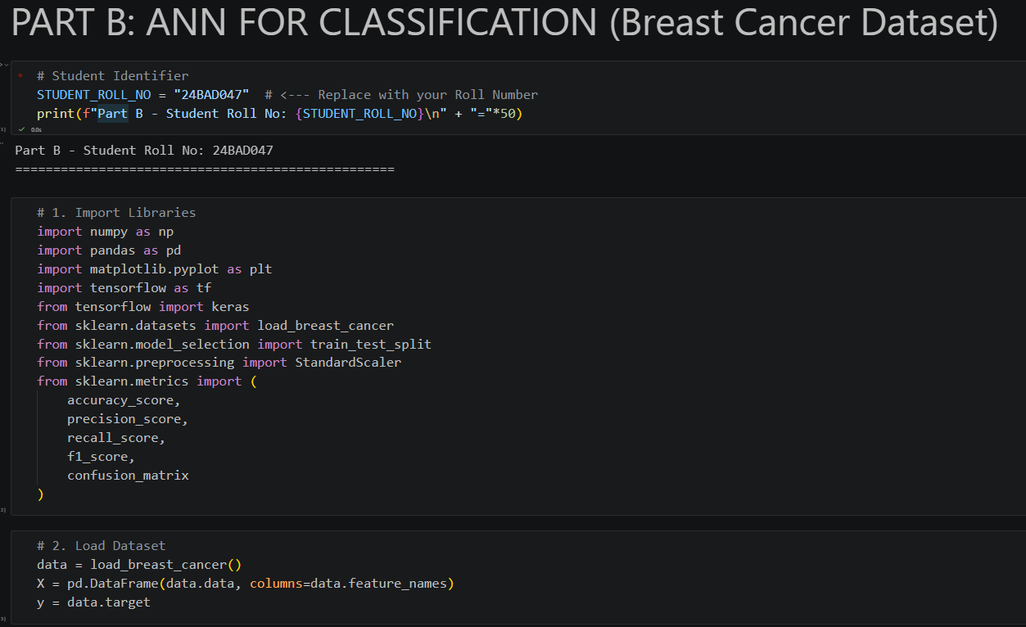

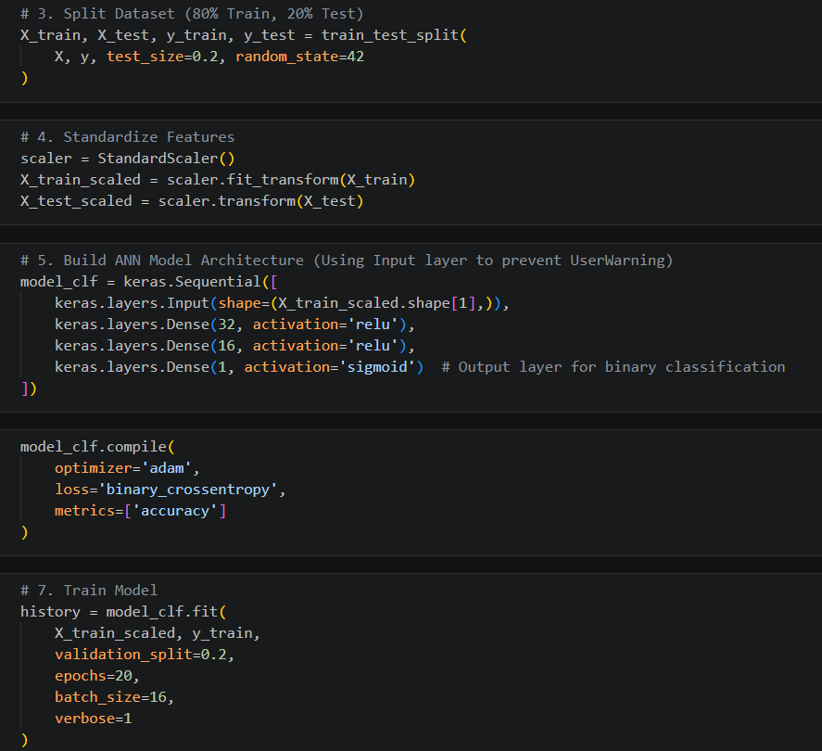
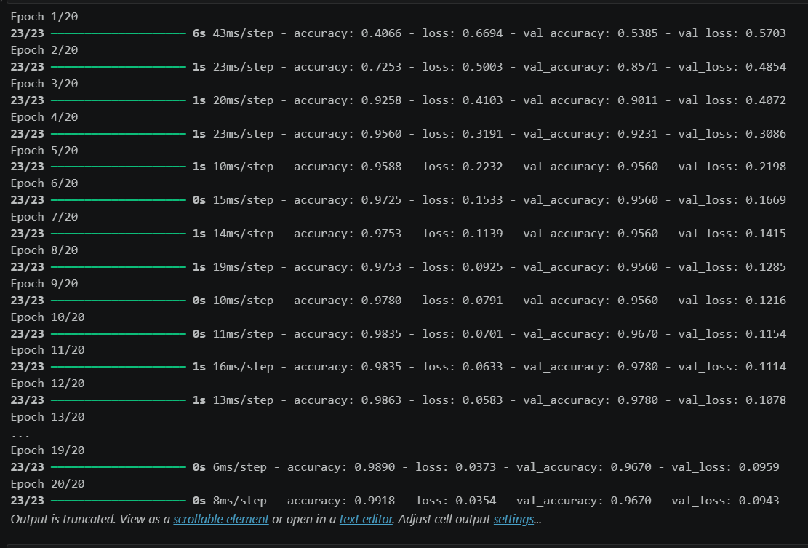

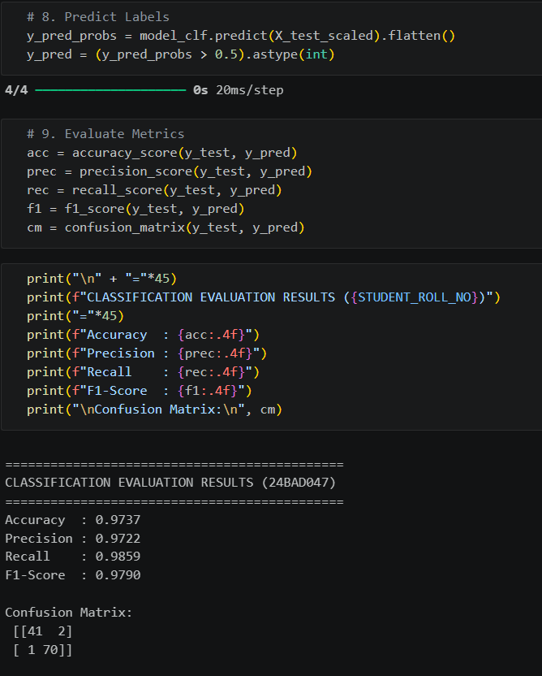

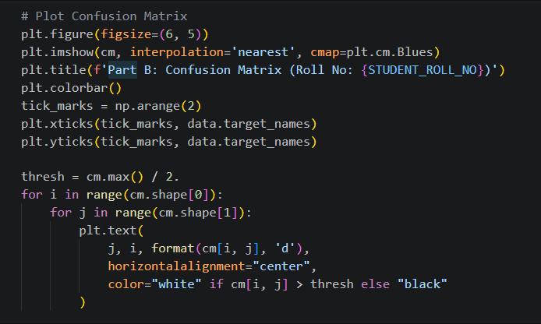
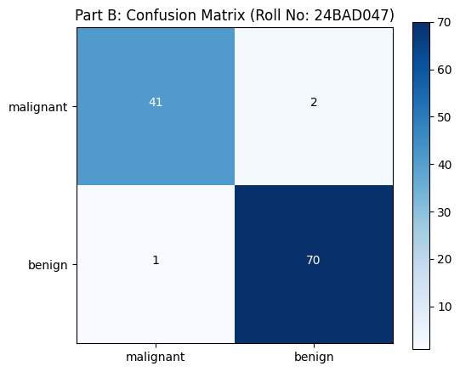

POST-LAB QUESTIONS (PROVIDE BRIEF ANSWERS TO THE FOLLOWING QUESTIONS)

- Why is the Adam optimizer commonly used in ANN training?
Adam optimizer is fast, efficient, and helps the ANN reach better accuracy during training.

- Compare Mean Squared Error (MSE) and Mean Absolute Error (MAE). Which metric is more sensitive to outliers?
• MSE: Squares the errors, so large errors have a bigger effect.
• MAE: Uses the absolute value of errors, making it easier to understand.
• MSE is more sensitive to outliers.

- Why is the sigmoid activation function used in binary classification?
The sigmoid function gives an output between 0 and 1, which represents the probability of two classes (Yes/No or 0/1).

- How does increasing the number of hidden layers affect the performance of an ANN?
More hidden layers can learn more complex patterns, but too many layers may increase training time and lead to overfitting.

- Compare the evaluation metrics used for regression and classification tasks. Why are different metrics required for these problems?
• Regression Metrics: MSE, MAE, RMSE (measure prediction error).
• Classification Metrics: Accuracy, Precision, Recall, F1-score, Confusion Matrix (measure how well the model classifies data).

ASSESSMENT
Description | Max Marks | Marks Awarded
Pre Lab Exercise | 5
In Lab Exercise | 10
Post Lab Exercise | 5
Viva | 10
Total | 30
Faculty Signature

